Restricted distribution IOC/IODE-XXVII/3.5.3/inf1

Paris, 18 March 2023

English only

**INTERGOVERNMENTAL OCEANOGRAPHIC COMMISSION**

(of UNESCO)

**Twenty-seventh Session of the IOC Committee on International Oceanographic Data and Information Exchange (IODE-XXVII)   
UNESCO Headquarters, Paris, 22-24 March 2023**

**ESTABLISHMENT OF A DATA ACQUISITION CENTRE FOR MARINE METEOROLOGICAL AND OCEANOGRAPHIC CLIMATE DATA WITHIN THE MARINE CLIMATE DATA SYSTEM**

**(provided by WMO)**

**ESTABLISHMENT OF A DATA ACQUISITION CENTRE FOR MARINE METEOROLOGICAL AND OCEANOGRAPHIC CLIMATE DATA WITHIN THE MARINE CLIMATE DATA SYSTEM**

The Marine Climate Data System (MCDS) was established at JCOMM-4 to formalize and coordinate the activities of existing data collection systems and to address gaps in order to produce a dedicated WMO-IOC operational data system with a view to compiling coherent marine meteorological and oceanographic (metocean) climate data sets of known quality, extending beyond the Essential Climate Variables (ECVs).

Centres for Marine Meteorological and Oceanographic Climate Data (CMOCs), Global Data Assembly Centres (GDACs), and Data Acquisition Centres (DACs) are the three tiers of the MCDS. The terms of reference for MCDS DACs are provided in Appendix 1 of the Guide to Marine Meteorological Services ([WMO-No. 471](https://library.wmo.int/index.php?lvl=notice_display&id=7469#.ZAh9CxXMIuV)).

The application received from the Lagrangian Drifter Laboratory (LDL) at the Scripps Institution of Oceanography (SIO), University of California San Diego, USA to operate as a DAC was assessed by an independent evaluation panel including IOC/IODE membership, following the process and criteria provided in the Guide to Marine Meteorological Services (WMO-No. 471), Chapter 9 and Appendix 1. The outcome of the evaluation and review by the team of experts independent from the applicant recommended that the centre be established and operated by the United States of America as an MCDS DAC for Drifting Buoys. This recommendation was approved by WMO 76th Executive Council [Resolution 3.2(8)/1 (EC-76)](https://meetings.wmo.int/EC-76/_layouts/15/WopiFrame.aspx?sourcedoc=/EC-76/English/2.%20PROVISIONAL%20REPORT%20(Approved%20documents)/EC-76-d03-2(8)-DATA-ACQUISITION-CENTRE-FOR-MARINE-DATA-approved_en.docx&action=default) subjected to parallel approval by the fifty-sixth Session of the IOC Executive Council.

IODE is requested to endorse the recommendation from the evaluation panel for the Lagrangian Drifter Laboratory (LDL) at the Scripps Institution of Oceanography (SIO), University of California San Diego, USA to operate as a DAC. The evaluation report is provided in Appendix 1.

**Appendix 1**

**Marine Climate Data System Evaluation Report for the application of Data Acquisition Center (DAC) from the Lagrangian Drifter Laboratory (LDL) at Scripps Institution of Oceanography, USA**

A formal application to operate as a Data Acquisition Center (DAC) for Drifting Buoys within the Marine Climate Data System (MCDS) was received from the Lagrangian Drifter Laboratory (LDL) at Scripps Institution of Oceanography, USA on November 22, 2021 (Annex I). The application was reviewed by the DAC Evaluation Committee established under the MCDS Evaluation Committee Terms of Reference (ToR) provided in Annex II.

In light of delays to the work of the JCOMM Data Management Coordination Group (DMCG) and Data Management Programme Area (DMPA) being reestablished following the WMO reform an ad hoc Evaluation Committee was established to assess the application. The committee was established with two members appointed by WMO (Eric Freeman (USA), David Berry (Switzerland)) and one member representing the IOC Global Ocean Observing System (GOOS) (Kevin O’Brien (USA)). The members were chosen based on past experience, familiarity with the Marine Climate Data System and work within the JCOMM Data Management Programme Area.

The Evaluation Committee, led by Eric Freeman (USA), assessed the application and completed a review of the evaluation criteria. A summary of the evaluation is provided in Annex III. The Evaluation Committee concurred the application satisfies the requirements of a DAC for Drifting Buoys and recommends the LDL to begin officially operating as a DAC for Oceanographic Lagrangian Surface Drifters in the MCDS.

ANNEX I

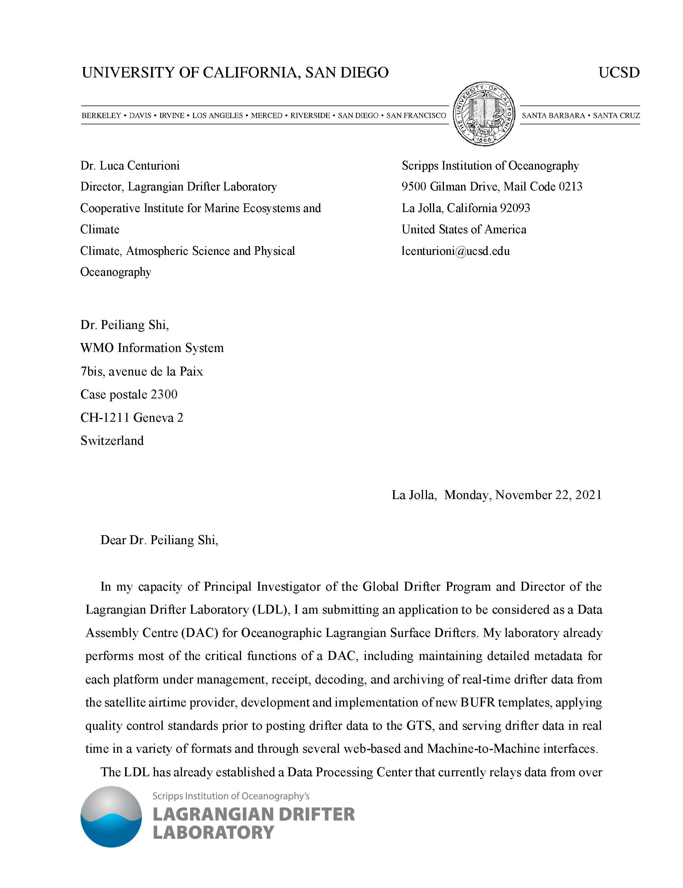

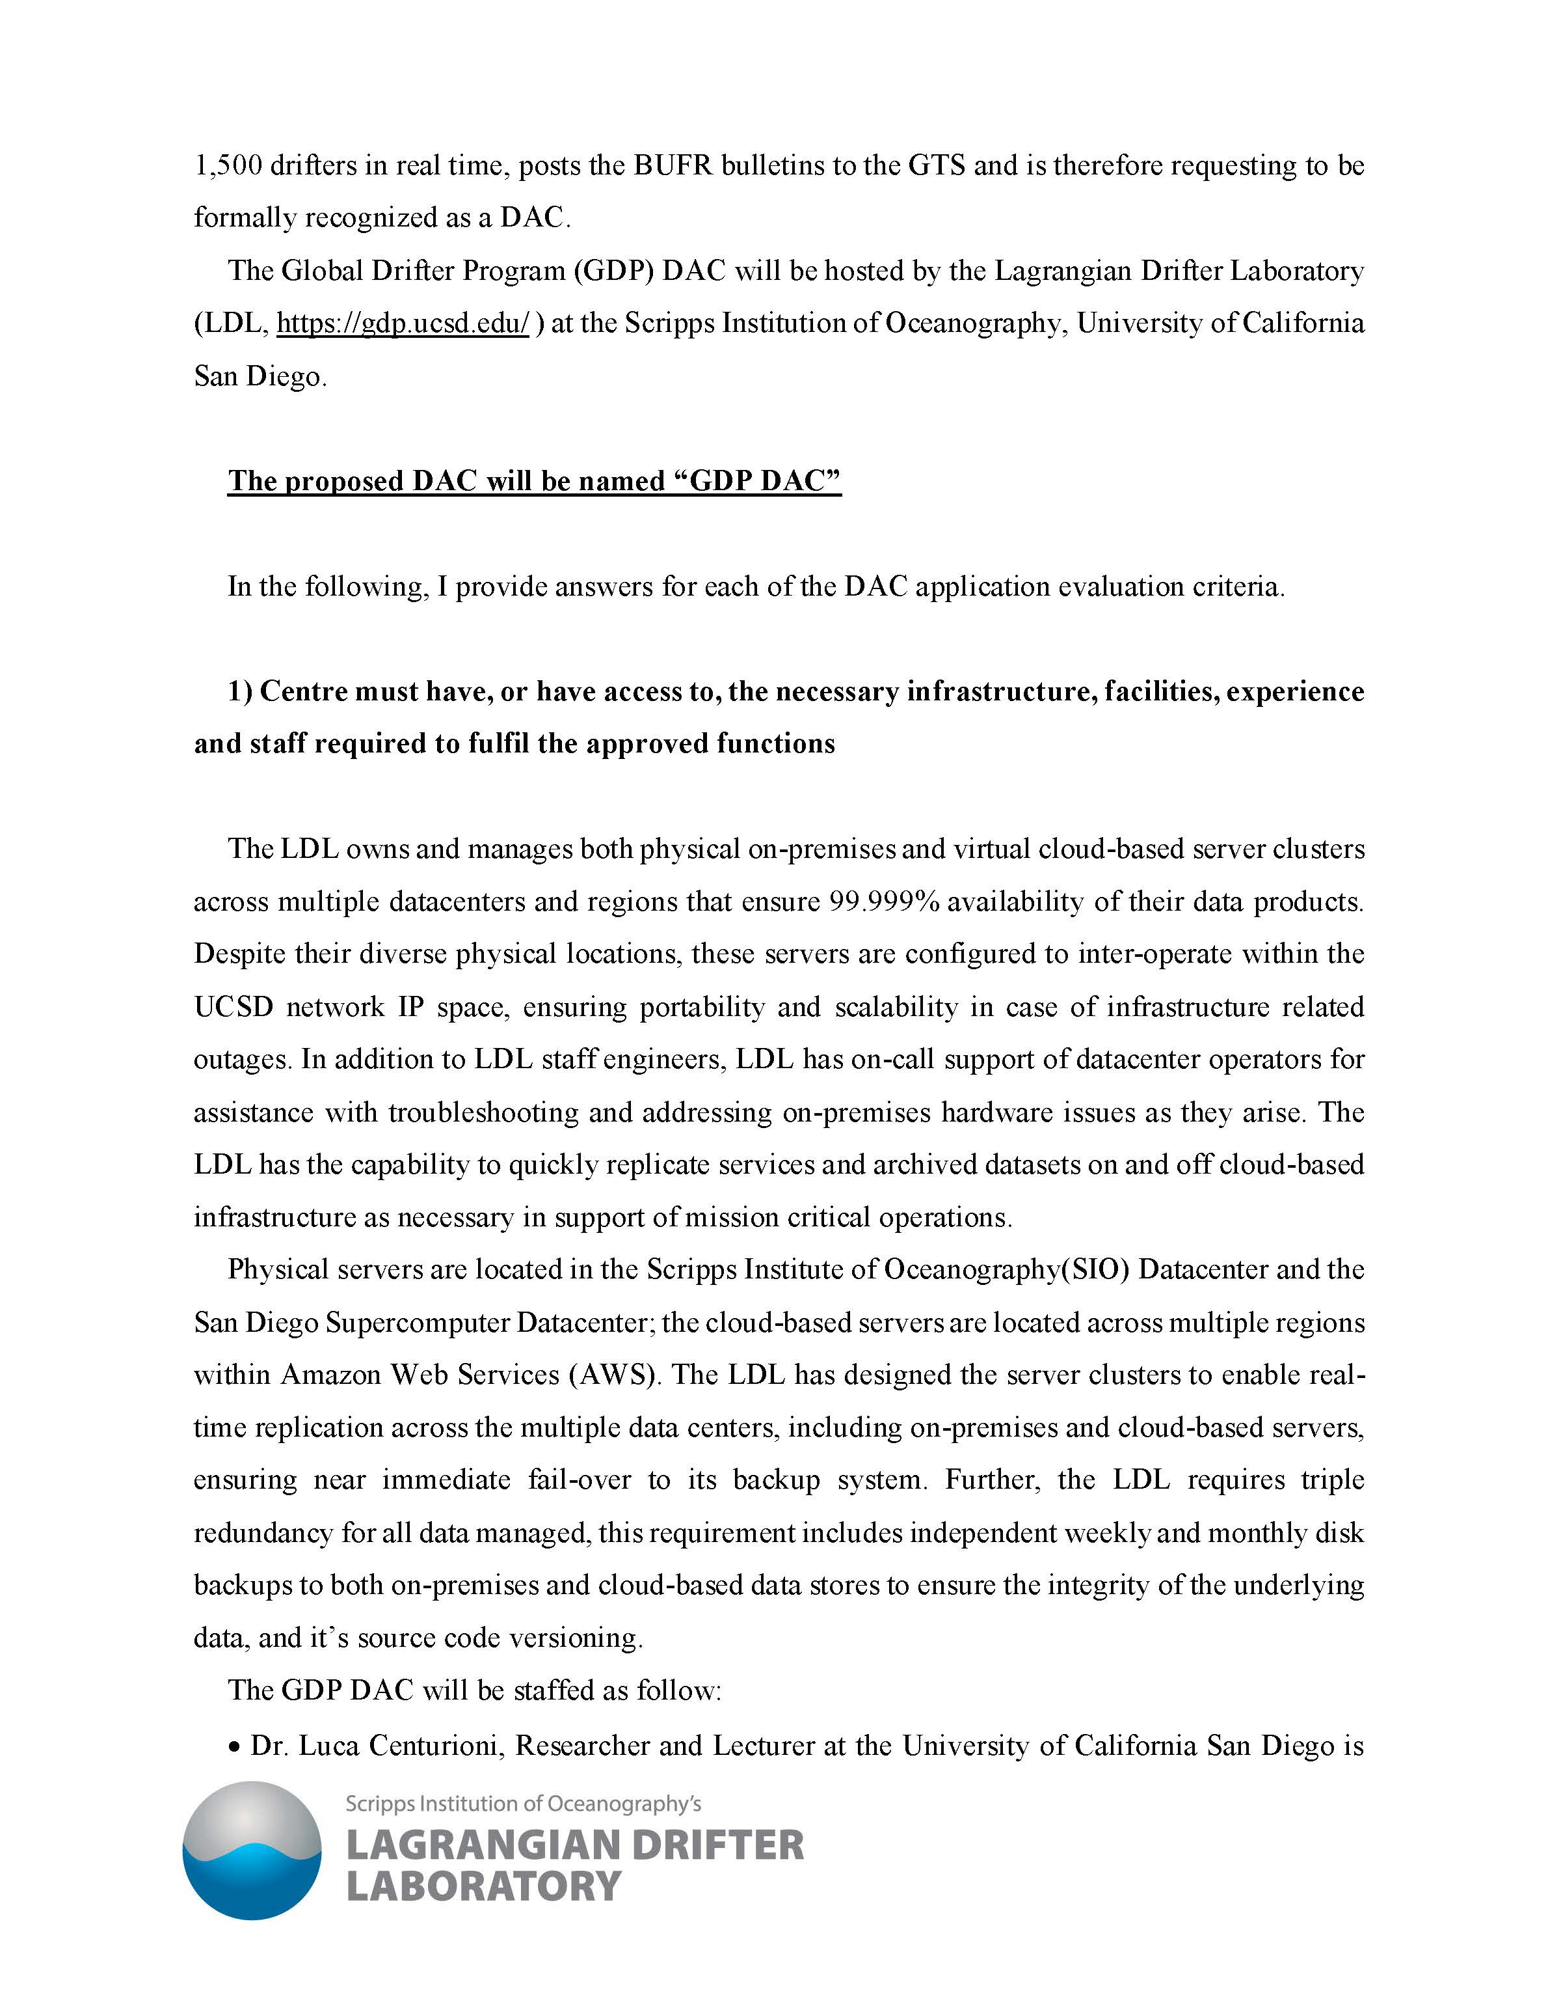

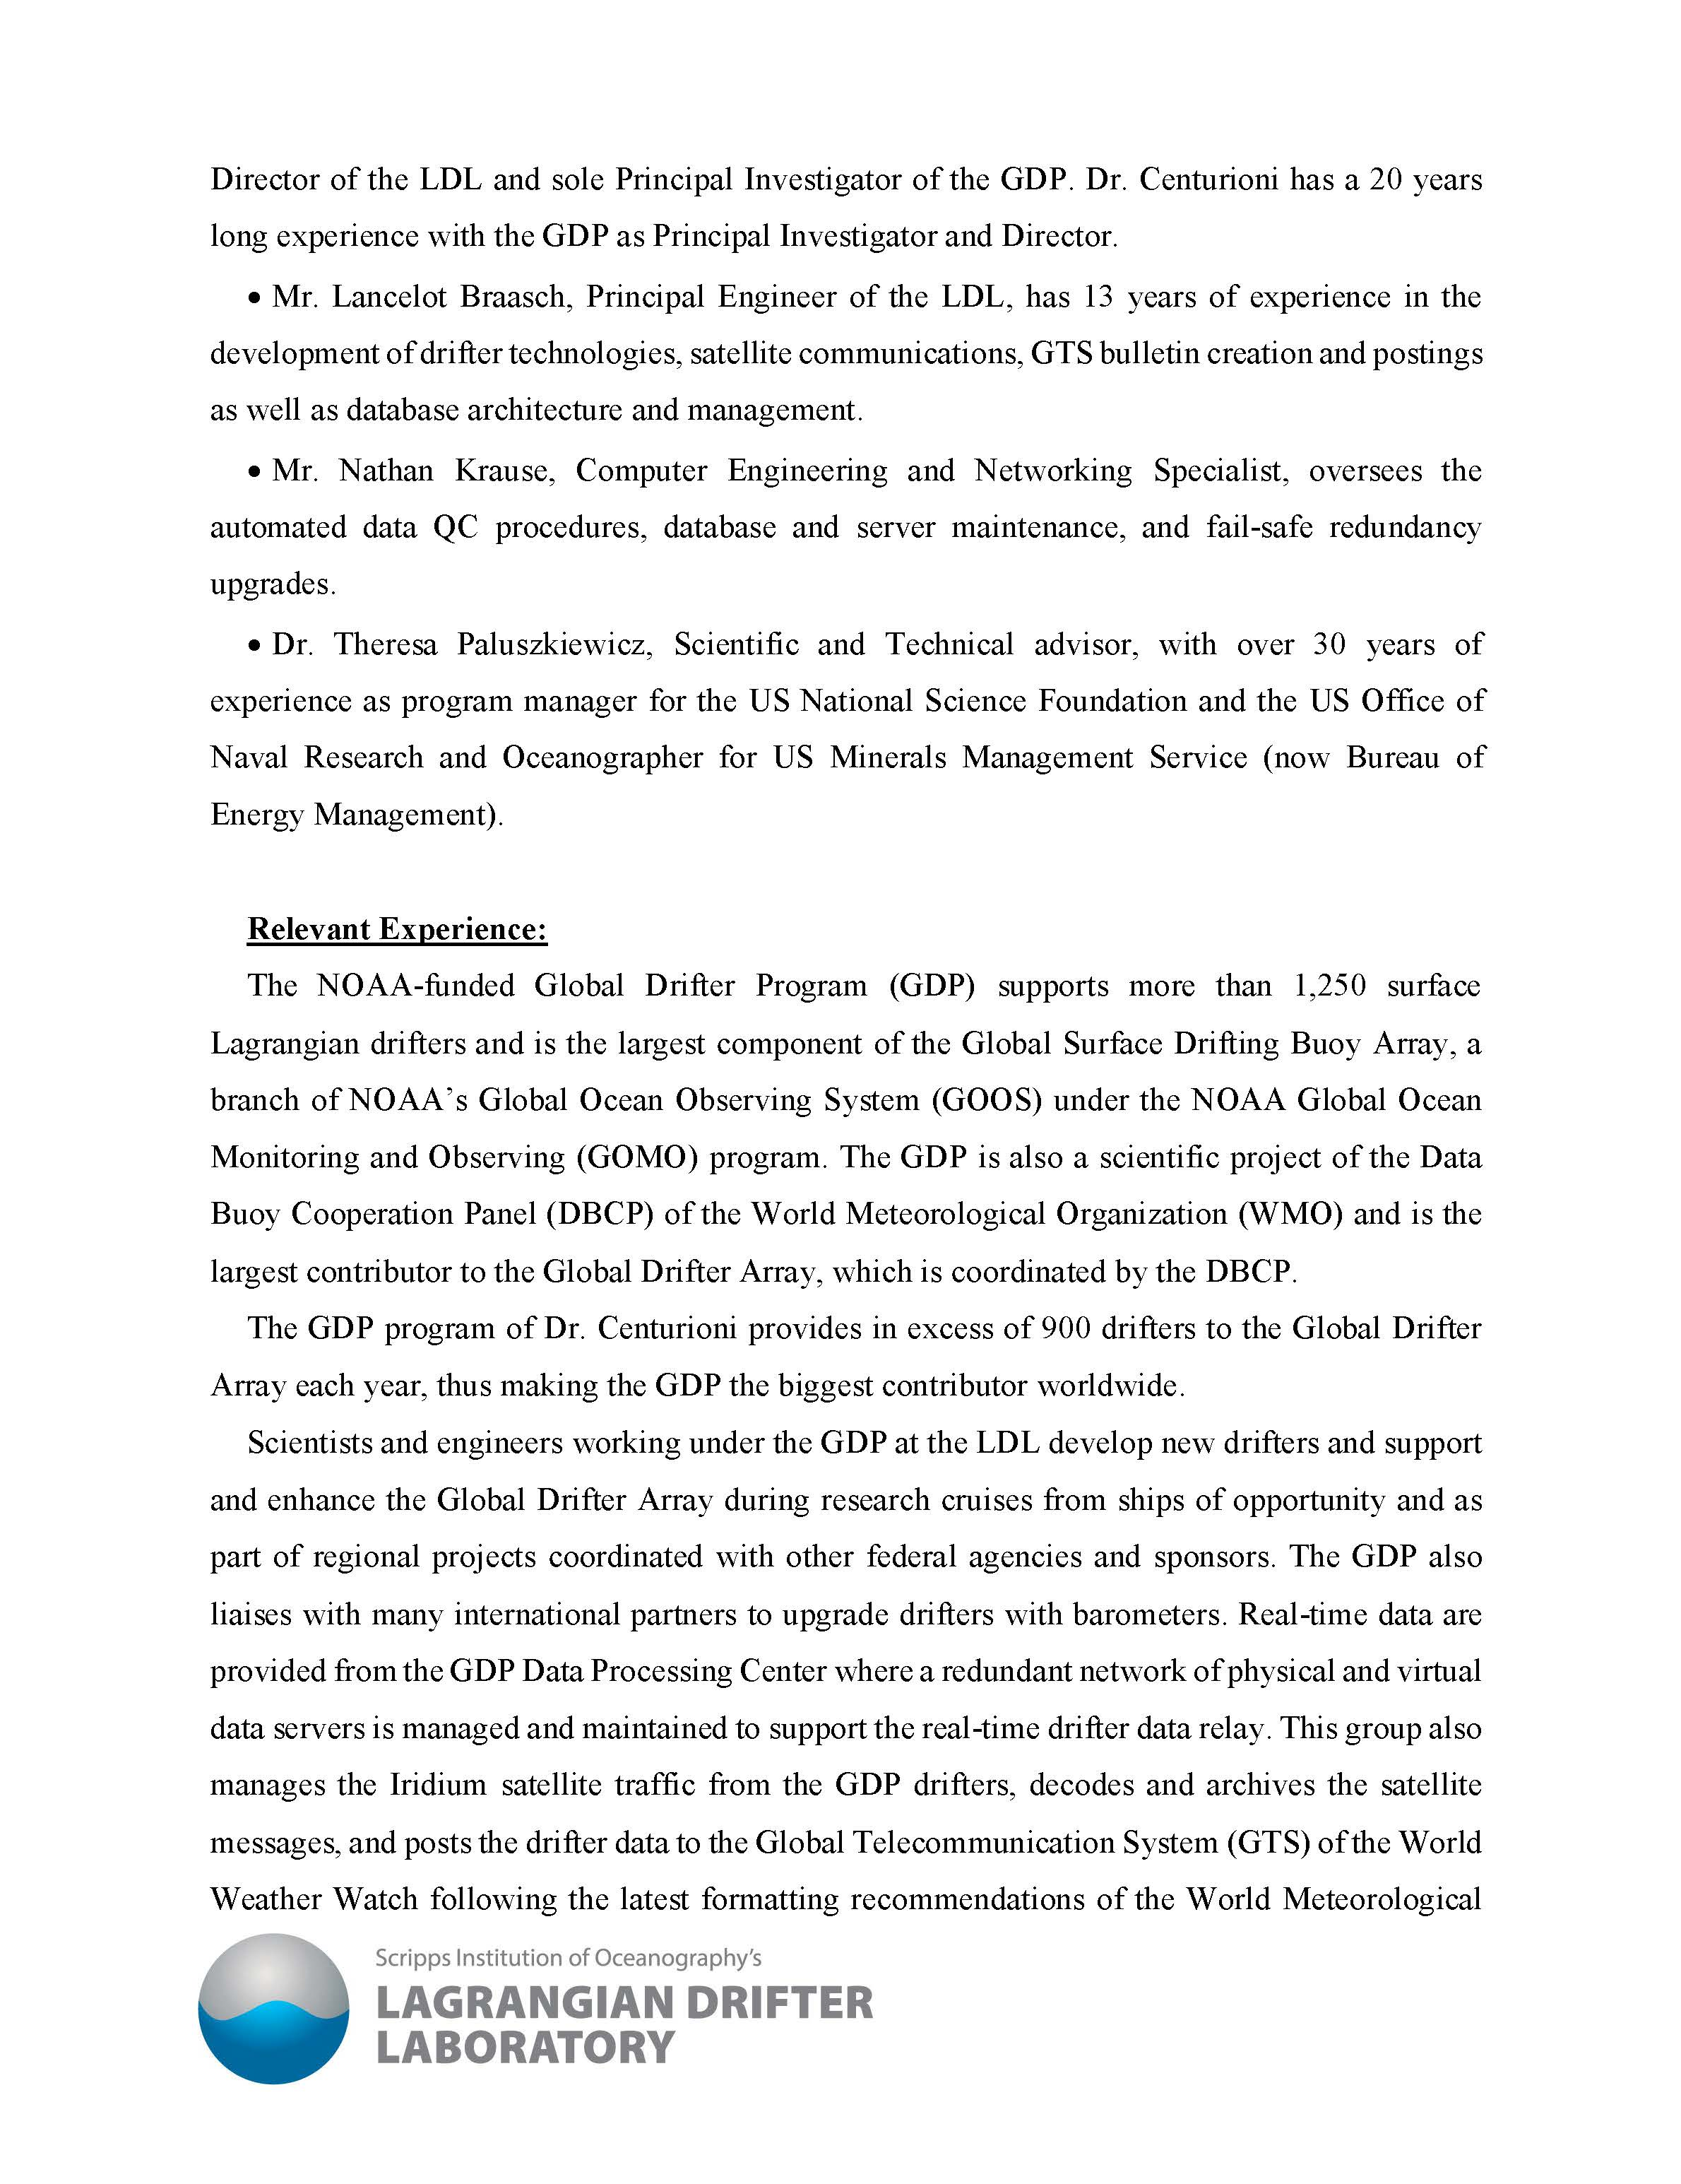

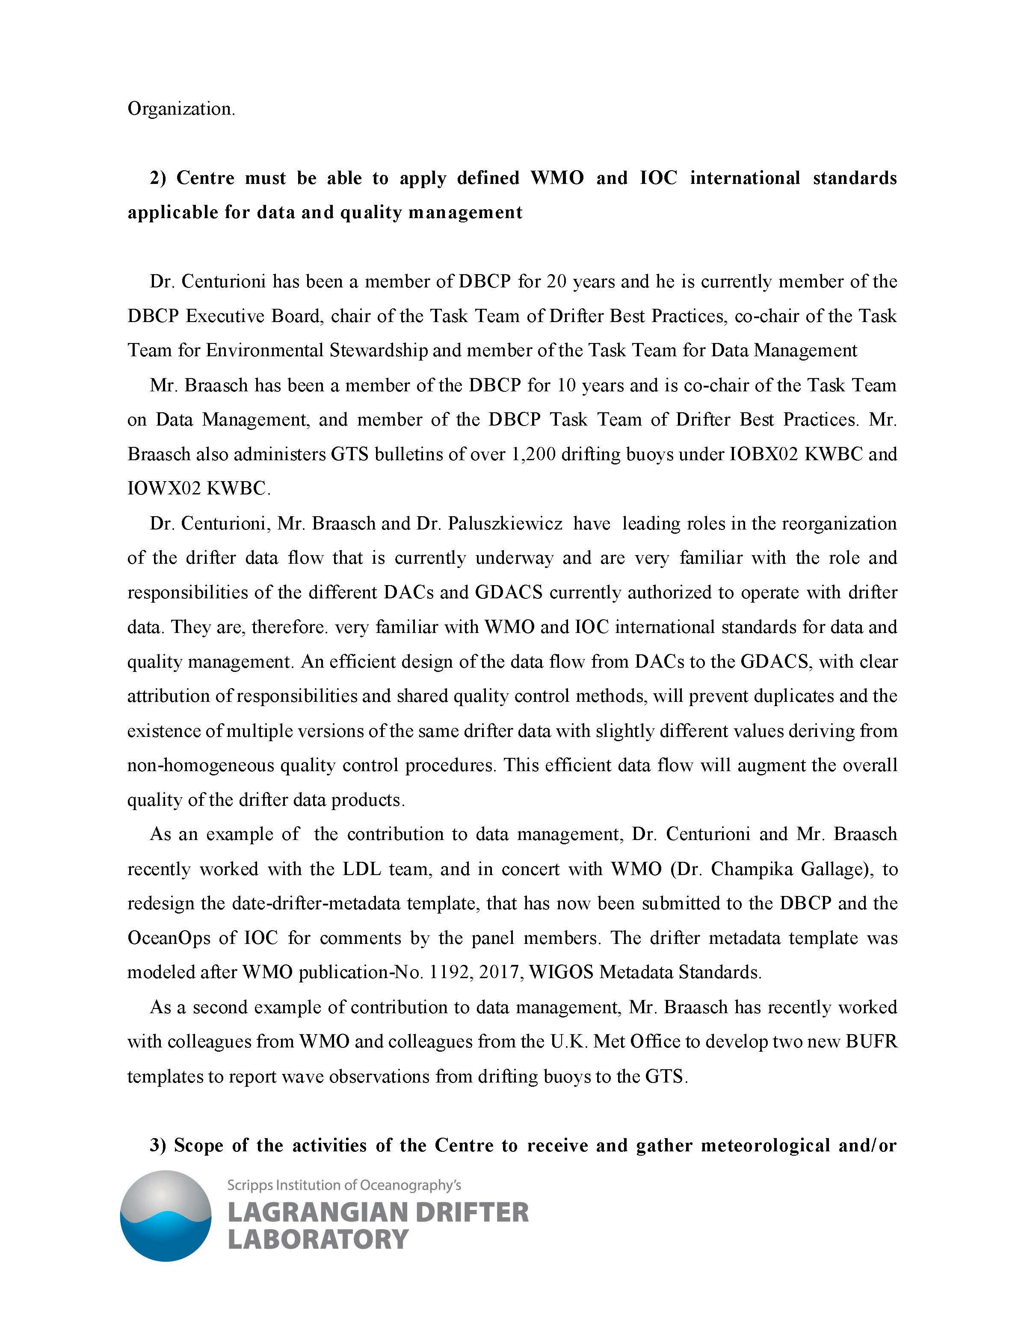

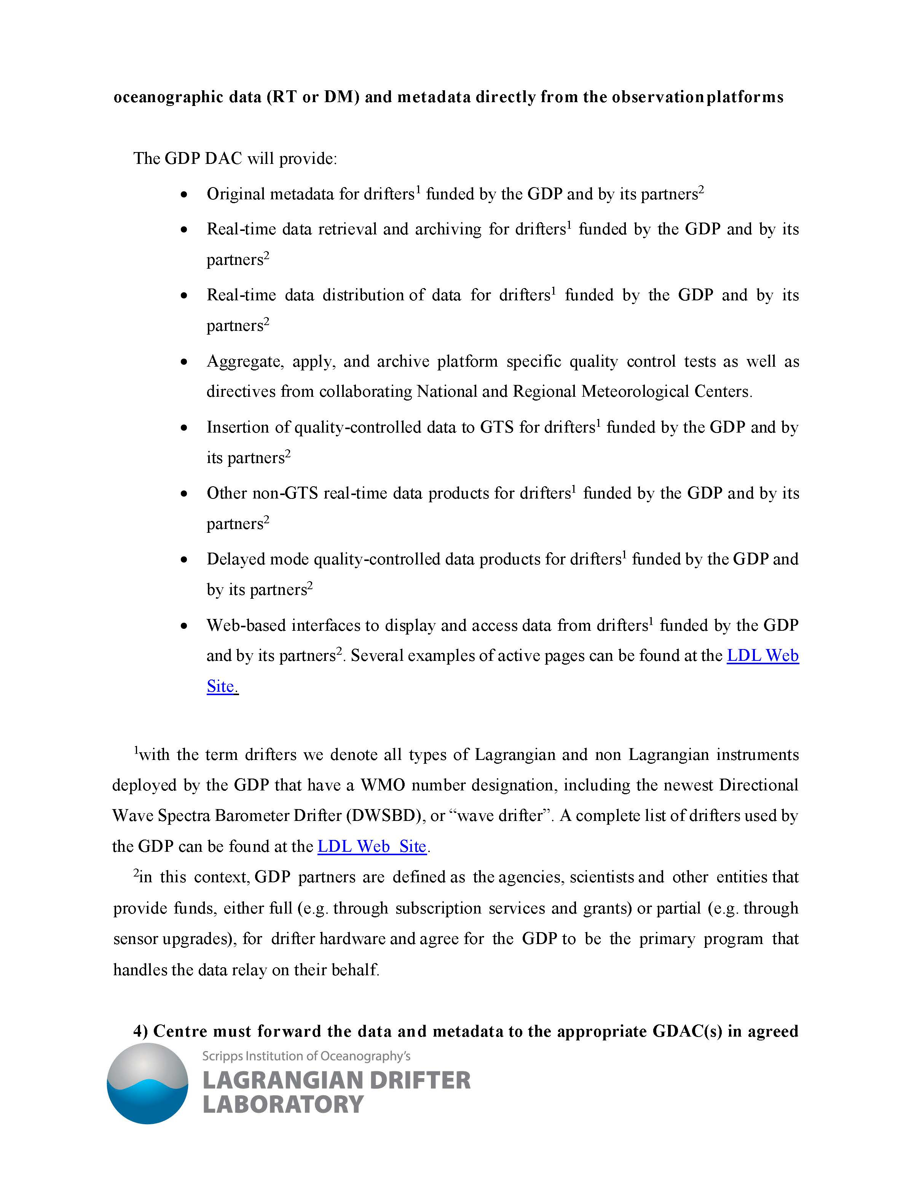

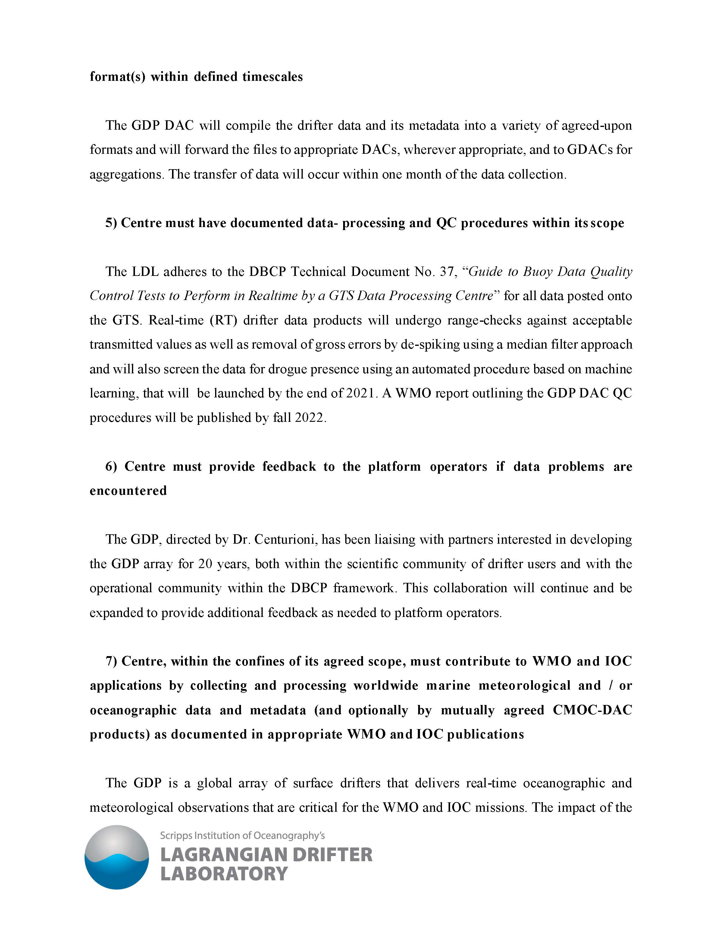

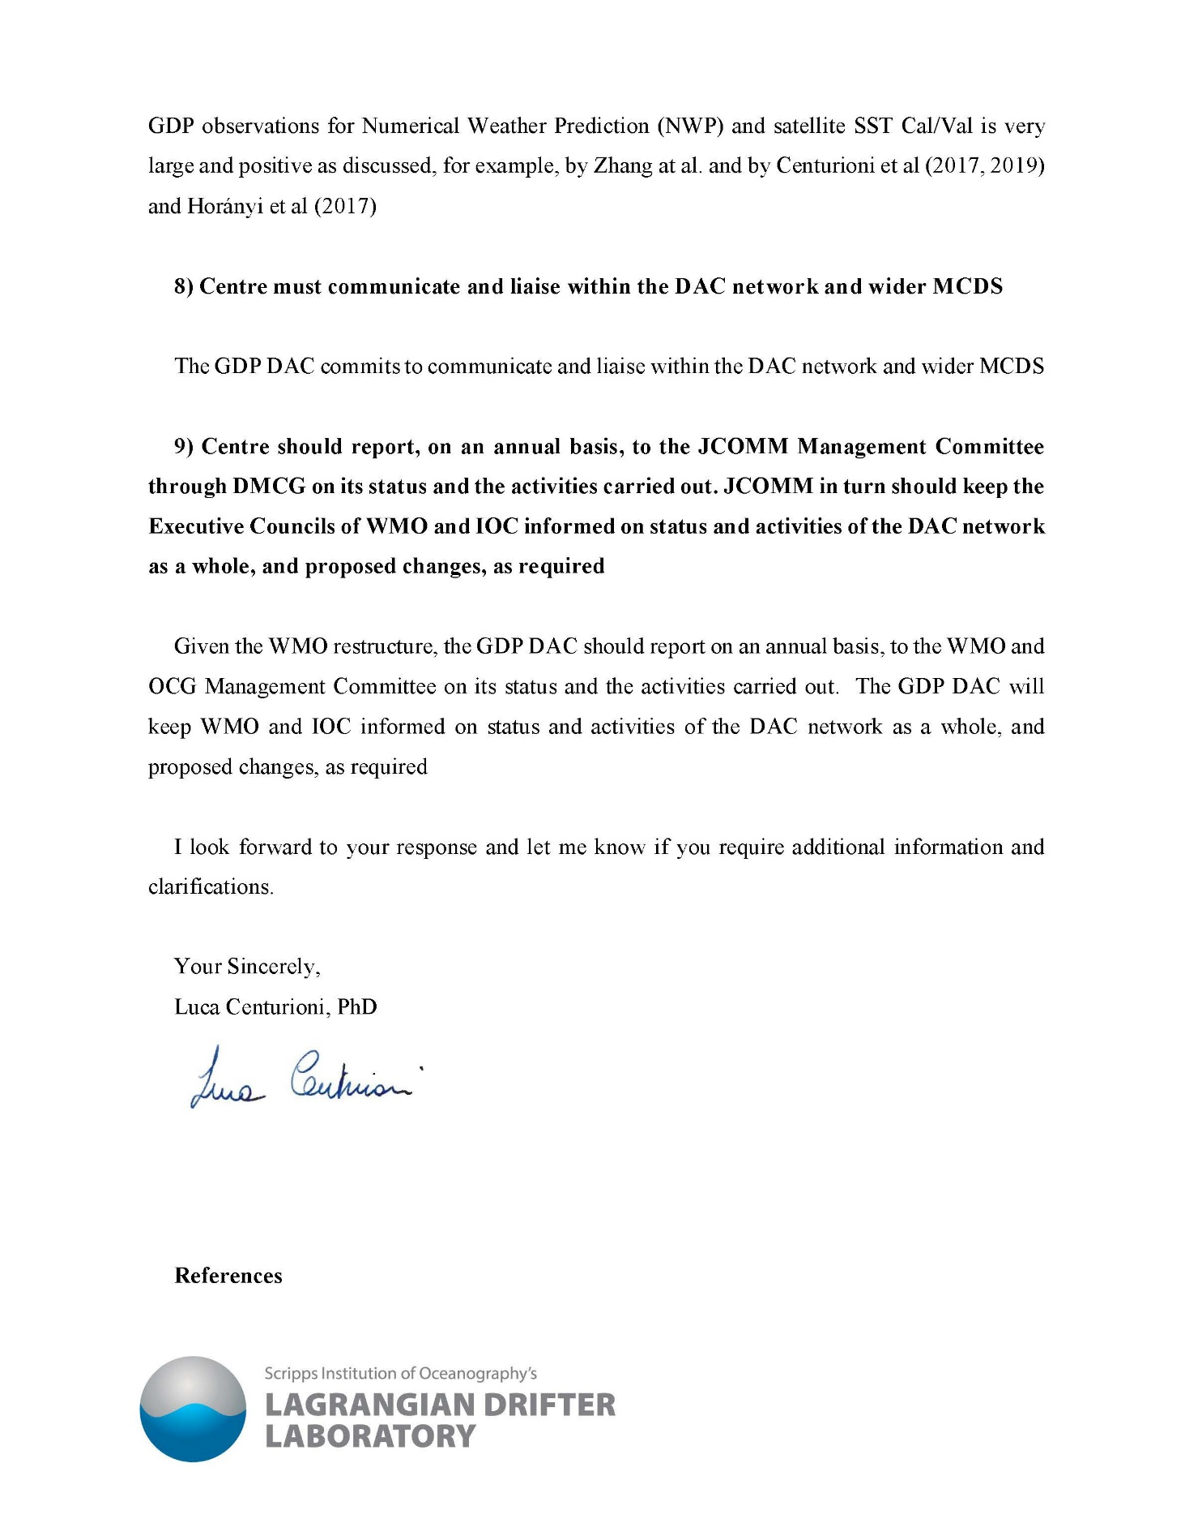

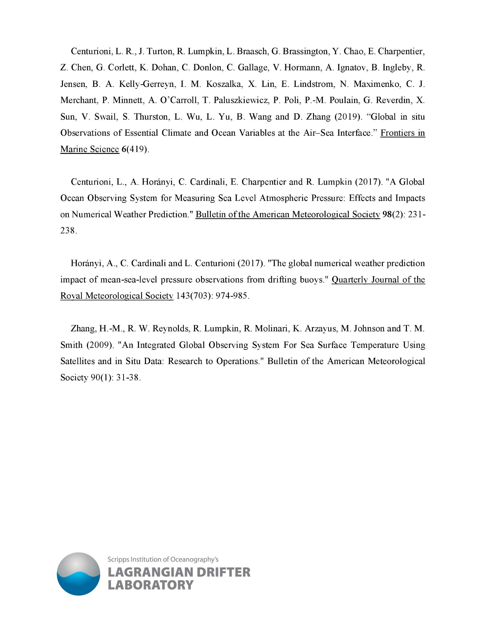

ANNEX II

# Evaluation Committee for Data Acquisition Centres (DACs) in the Marine Climate Data System (MCDS) of JCOMM

Terms of Reference

1. The Committee shall be nominated by the JCB co-Presidents. The Committee shall have a minimum of 3 members, including at least one from the IOC of UNESCO and one from WMO.
2. None of the Committee members should belong to the applicant organization, In such situation the committee member should voluntarily be removed from that particular evaluation process and an alternate member be nominated by the JCB co- Presidents.
3. Review submitted Evaluation Criteria provided by potential DACs in order to verify that the DAC functions are compatible with the requirements of the scope of the DAC as outlined in [WMO Publication No. 471](https://library.wmo.int/doc_num.php?explnum_id=5445).
4. Report to JCB co-Presidents with recommendations of a new DAC candidate’s and Evaluation Criteria and Evaluation Results.

# Members:

1. Eric Freeman (USA, NOAA/NCEI)
2. David Berry (CH, WMO)
3. Kevin O’Brien (USA, NOAA/PMEL and IOC GOOS)

**ANNEX IV**

**Data Acquisition Center Evaluation Results**

|  |  |  |
| --- | --- | --- |
|  | **Criteria** | **How do you meet the requirement?** |
| 1 | Centre must have, or have access to, the necessary infrastructure, facilities, experience and staff required to fulfill the approved functions; | The Lagrangian Drifter Laboratory (LDL) at Scripps Institution of Oceanography has a long, proven track record in drifting buoy data management, and have the staff and resources necessary to perform the approved functions of the DAC. |
| 2 | Centre must be able to apply defined WMO and IOC international standards applicable for Data and Quality Management | Considering the long-term participation in the Data Buoy Cooperation Panel (DBCP), the LDL are highly involved in applicable QC and buoy design standards and community best practices development. They apply the most current QC standards and are adaptable to future QC changes and needs, as recommended by IOC and WMO. |
| 3 | Scope of the activities of the Centre to receive and gather meteorological and/or oceanographic data (real-time or delayed-mode) and metadata directly from the observation platforms | The LDL has been receiving real-time data from the global drifters, performing QC on the data, and ensuring its availability for many years. These activities will compliment those of other DACs for drifting buoys. |
| 4 | Centre must forward the data and metadata to the appropriate GDAC(s) in agreed format(s) within defined time-scales | The LDL retrieve real-time GTS data, QC the data, and insert the QC’d data back onto the WMO GTS. Metadata is provided to OceanOps and the LDL commits to sending the delayed mode data to the appropriate GDACs for aggregation.  Recommendations:   1. At the first annual review, it is recommended that the DAC provide status information on these DAC/GDAC collaborations/exchanges. 2. Ensure that platform metadata transmission with OceanOPS is done in a machine-to-machine process – hopefully a process that is similar to other global networks. |
| 5 | Centre must have documented data processing and quality control procedures within its scope | The LDL adheres to processing and QC procedures for real-time GTS data as documented in DBCP T.D. 37, the community standard. |
| 6 | Centre must provide feedback to the platform operators if data problems are encountered | The LDL is in direct contact with DBCP platform operators/partners and data users in the scientific community, and has been for decades. |
| 7 | Centre, within the confines of its agreed scope, must contribute to WMO and IOC Applications by collecting and processing worldwide marine-meteorological and /or oceanographic data and metadata (and optionally by mutually agreed CMOC-DAC products) as documented in appropriate WMO and IOC publications | The data and metadata collected by LDL as part of the Global Drifter Programme (GDP) have supported WMO and IOC applications for decades and are well documented in peer reviewed literature and technical documents. There is no reason to believe that this will not continue in the future under the formal role of DAC in the MCDS. |
| 8 | Centre must communicate and liaise within the DAC network and the wider MCDS | The LDL, along with other GDP members, is integrated into the DBCP, MCDS and other international communities, including the GOOS and IOC.  Recommendation:  Whilst the coordination mechanism for the wider MCDS needs to be redefined following WMO reform, it is recommended that the LDL continue to liaise with these groups, including the GOOS Observations Coordination Group (OCG) as the OCG develops a data implementation strategy for the global ocean observing networks. |
| 9 | Centre should report, on an annual basis, to the JCOMM Management Committee through the DMCG on its status and the activities carried out. JCOMM in turn should keep the Executive Councils of the WMO and the UNESCO/IOC Assembly informed on status and activities of the DAC network as a whole, and proposed changes, as required | Though JCOMM no longer exists, the LDL is performing this task as an integral part of the DBCP, which now reports directly to the GOOS OCG. Reports are provided at the annual DBCP and OCG meetings, and at quarterly roundtables, when relevant. |